Cleaning the Heart's Noise from Brain Signals: A Large-Cohort Study of Cardiac Field Artifact in EEG
Nir Cafri^{1,3}, Felix Benninger^{2,3}, Pablo Blinder^{1,2}
¹Department of Neurobiology, School of Neurobiology, Biochemistry and Biophysics, George S. Wise Faculty of Life Sciences, Tel Aviv University, Tel Aviv, Israel
²Sagol School of Neuroscience, Tel Aviv University, Tel Aviv, Israel
³Department of Neurology, Rabin Medical Center, Beilinson Hospital and Tel-Aviv University, Petah Tikva, Israel
Correspondence: pb@tauex.tau.ac.il

Abstract
The electrical field of the heart is volume-conducted to the scalp and adds a cardiac field artifact (CFA) to every EEG recording. CFA is a source of noise for any EEG analysis and a direct confound for heartbeat-locked measures such as heartbeat-evoked potentials (HEPs), yet it has been characterised only in small samples and is usually assumed to be constant across people and to be removed by excluding the QRS complex. We quantified CFA in 7,995 polysomnography patients (98,203 channel-recordings) from the Human Sleep Project, the largest sample in which CFA has been measured. Per channel, the R-peak-locked EEG average was regressed on the ECG average, excluding a ±50 ms QRS interval. Outside the QRS interval, the ECG explained a mean R² of 0.32 of heartbeat-locked EEG variance, and removing the ECG-related independent component reduced this variance by a median of 28%. CFA ranged from negligible to near-complete between individual patients and varied across electrodes. It increased with BMI (r = 0.11, p = 4.3e-17; n = 6,127) and was higher in men than in women (0.37 vs. 0.32, p = 1.5e-21), independently of BMI and at every segment duration. Segment duration had a significant effect: in 7,079 duration-matched patients, mean R² rose from 0.30 at 5 min to 0.42 at 60 min (Friedman p < 1e-300). CFA is therefore a participant-, channel-, and duration-dependent noise source; EEG studies should estimate it per channel, report and justify segment length, and account for BMI and sex when comparing groups.

Highlights
• In the largest study of cardiac field artifact (CFA) to date (7,995 patients, 98,203 EEG channel-recordings), the ECG explained a mean 32% of heartbeat-locked EEG variance even after QRS exclusion.
• CFA increased with BMI (r = 0.11, p = 4.3e-17) and was higher in men than in women (0.37 vs. 0.32, p = 1.5e-21); the sex difference was independent of BMI (BMI-adjusted p = 3.2e-13).
• Segment duration significantly changed CFA estimates (mean R² 0.30 at 5 min vs. 0.42 at 60 min), so the analysis window must be reported and justified.
Keywords: cardiac field artifact; EEG artifact; ECG; body mass index; sex differences; segment duration; heartbeat-evoked potential; independent component analysis; polysomnography

1. Introduction
The heart is one of the strongest bioelectrical generators in the body, and its electrical field is volume-conducted through the tissues of the chest, neck, and head to the scalp. Every EEG recording therefore contains a cardiac field artifact (CFA): a heartbeat-locked deflection that is not of cortical origin¹⁻⁴. Because CFA repeats with each heartbeat, it adds structured noise to any EEG measure computed over time^{3,4}, and it is preserved, rather than averaged out, in analyses that are time-locked to the R-peak. The heartbeat-evoked potential (HEP), the R-peak-locked EEG response used to study cardiac interoception⁵⁻⁷, is the clearest example: CFA and genuine cortical responses to the heartbeat share the same time-locking event^{1,6}. The standard mitigation is to exclude a short interval around the QRS complex (typically ±30–50 ms) and, in some studies, to remove an ECG-related independent component⁶⁻⁸.
Despite its ubiquity, CFA has been characterised only in single cohorts of a few tens of participants^{1,2}, samples that cannot detect modest differences between people. As a result, CFA is usually treated as an approximately constant property of the recording, which a fixed QRS exclusion is assumed to remove. Recent reviews have documented considerable heterogeneity in how CFA is handled and have noted that inconsistent preprocessing limits reproducibility and clinical interpretation⁷⁻⁹. If the amount of CFA differs systematically between people or between analysis choices, then a group difference in heartbeat-locked EEG may reflect cardiac electrophysiology, tissue conductivity, or electrode geometry rather than brain activity^{2,6,10,11}.
Three factors are of particular interest. First, body composition alters the geometry and conductivity of the path between the heart and the scalp; in surface ECG, subcutaneous fat attenuates cardiac voltage, and correcting voltage for body fat changes its relationship with cardiac structure¹², and obesity is associated with low QRS voltage and shifts of the cardiac electrical axis¹³. BMI, although an indirect measure of adiposity, is available in most clinical datasets. Second, men and women differ in thoracic anatomy, heart size, and body-fat distribution, so CFA may differ by sex, a common grouping variable in EEG research. Third, the analysis itself matters: CFA is estimated from averages over heartbeats, and averages over fewer events are less reliable¹⁴, so the apparent amount of contamination may depend on the chosen segment duration. To our knowledge, none of these factors has been examined at the population level.
Here, we quantified CFA in clinical polysomnography recordings from 7,995 patients in the Human Sleep Project, a publicly available, curated dataset¹⁵, the largest sample in which CFA has been measured. We used two complementary estimators: a model-free estimator that regresses each channel's R-peak-locked EEG average on the same patient's R-peak-locked ECG average, and a model-based estimator that applies ECG-informed ICA. We illustrate the range of CFA in individual patients, describe its scalp distribution, and test its dependence on BMI, sex, age, and segment duration (5–60 min). We hypothesised that ECG-related variance would persist outside the QRS interval, that it would be greater with higher BMI and differ by sex, and that it would increase with segment duration as the heartbeat-locked average became more stable.

2. Methods

2.1 Cohort and recordings
This study is a secondary analysis of existing polysomnography recordings; no recordings were acquired for this study. Patient data were taken from the Human Sleep Project¹⁵, a publicly available, curated dataset of clinical polysomnography recordings with linked electronic health records (EHR), distributed through the Brain Data Science Platform. BMI was computed from each patient's median height and weight recorded in the EHR vitals and admission tables; values outside 10–80 kg/m² were excluded as implausible. EEG channels were identified by matching channel labels against standard 10-20/10-10 electrode names, thereby excluding intracranial depth electrodes and auxiliary/DC channels; at least two EEG channels were required. The ECG channel was identified by label pattern matching (ECG/EKG), and the first matching lead was used. Cohort characteristics are reported in Section 3.1.

2.2 Window selection, R-peak detection, and preprocessing
For the main analysis, a single 10-min analysis window was selected for each recording by a seeded, reproducible random search (uniformly distributed start times; up to 10 attempts). R-peaks were detected on the ECG of each candidate window before the analysis filter (see below and Table 1): the median-subtracted signal was band-pass filtered at 5–25 Hz (third-order zero-phase Butterworth), rectified, and peaks were identified with a minimum inter-peak distance of 300 ms and a prominence threshold of three times the median absolute deviation of the rectified signal; rectification made detection insensitive to ECG polarity. A window was accepted if (i) at least 70% of EEG channels passed signal-quality criteria (≥99.9% finite samples; standard deviation 0.1–500 µV; peak-to-peak amplitude ≤5,000 µV; <20% flat samples), (ii) the mean heart rate was 35–180 beats/min, and (iii) at least 70% of R-R intervals lay between 0.33 and 2.0 s. The accepted window was then band-pass filtered between 1 Hz and min(100 Hz, Nyquist − 0.5 Hz) using a zero-phase FIR filter in MNE-Python¹⁶; because 86% of recordings were sampled at 200 Hz, the upper edge lay just below the Nyquist frequency in most recordings. The same filter was applied to the EEG and ECG channels, and signals were analysed in µV at their native sampling rate without re-referencing, channel interpolation, or amplitude-based rejection, so that CFA was estimated in minimally processed data. To test the effect of segment duration, the same procedure was repeated with windows of 5, 20, 30, 45, and 60 min (see Section 2.7). All window-selection, quality-control, and preprocessing parameters are summarised in Table 1.
Table 1. Window selection, quality control, and preprocessing parameters.
Step | Parameters
Window selection | Seeded random search, uniformly distributed start times, up to 10 attempts; 10 min (main analysis), 5–60 min (duration analysis, see Section 2.7)
R-peak detection | Median subtraction; 5–25 Hz third-order zero-phase Butterworth band-pass; rectification; minimum inter-peak distance 300 ms; prominence ≥3 × MAD
EEG channel quality | ≥99.9% finite samples; SD 0.1–500 µV; peak-to-peak ≤5,000 µV; <20% flat samples
Window acceptance | ≥70% of EEG channels pass quality criteria; mean heart rate 35–180 beats/min; ≥70% of R-R intervals 0.33–2.0 s
Analysis filter | Zero-phase FIR band-pass, 1 Hz to min(100 Hz, Nyquist − 0.5 Hz), MNE-Python; applied to EEG and ECG
Signal handling | Native sampling rate, µV; no re-referencing, channel interpolation, or amplitude-based rejection
HEP epochs | −300 to 400 ms around each R-peak; no baseline correction; ≥20 epochs; ±50 ms QRS exclusion for outside-QRS R² (see Section 2.3)

2.3 Model-free CFA estimator: HEP-vs-ECG regression
HEP epochs spanned -300 to 400 ms relative to each detected R-peak; epochs extending beyond the window edges were discarded, no baseline correction was applied, and recordings with fewer than 20 epochs were excluded (median 940 epochs per 10-min window). For each patient and EEG channel, the R-peak-locked evoked average (mean across epochs) was computed, together with the evoked average of the patient's ECG lead over the same epoch window. The squared zero-lag Pearson correlation (R²) between the two evoked waveforms was taken as the fraction of HEP variance in that channel shared with the ECG and used as an index of CFA. R² was computed over the full epoch and over the samples outside a ±50 ms QRS-exclusion window, as is standard in HEP analysis⁸. This estimator does not depend on the ability of ICA to isolate a cardiac source; rather, it tests directly the extent to which the averaged scalp waveform is a linearly scaled (and offset) copy of the averaged ECG. For patient-level analyses (see Section 2.7), channel-level R² values were averaged across each patient's channels at the six well-covered sites (see Section 2.5) and, for patients with more than one recording, across recordings (patient-mean CFA R²).

2.4 Model-based CFA estimator: ECG-informed ICA
In parallel, ICA¹⁷ (extended Picard algorithm¹⁸; min(15, number of EEG channels − 1) components; 500 iterations; fixed random seed) was fitted to the filtered EEG of the same 10-min window used for the regression estimator. Components whose correlation with the ECG channel exceeded the default threshold were identified as ECG-related using the correlation-based scoring implemented in MNE-Python¹⁶; if none did, the component with the highest absolute score was used (two components were flagged in 49 of 13,624 recordings). Rather than each component's share of continuous-signal variance, its mixing-weighted contribution to each channel was evaluated on the R-peak-locked evoked average, thereby quantifying the fraction of heartbeat-evoked signal that the component explains. In addition, the effect of artifact removal was measured directly by comparing the HEP variance of each channel before and after excluding the ECG-related component through ICA back-projection, yielding the realised percentage reduction in variance, 100 × (pre - post)/pre, rather than the nominal share of the component. For Figure 2b, the ratio of ECG-related component variance to residual variance (SNR) was also computed for each channel-recording.

2.5 Channel canonicalisation and minimum coverage
Channel labels were mapped to their scalp-side 10-20 site, and labels corresponding only to a reference electrode were excluded. Figure 2c–d includes all canonical sites recorded in at least 500 patients. Analyses requiring comparison across conditions or estimators at a common set of electrodes (see Sections 3.4–3.6, S2–S4) were restricted to sites present in at least 50% of the patients included in that analysis. In practice, this criterion retained six sites (F3, F4, C3, C4, O1, O2; each present in 96–100% of patients), which constitute the predominant montage of the dataset.

2.6 EEG-ECG cross-correlation and mutual information
The EEG-ECG relationship was further characterised in a separate subsample of 150 patients (Supplementary Figures S3–S4; 148 with usable cross-correlation and mutual-information data). Lag-resolved cross-correlation was computed as the Pearson correlation between each channel's evoked waveform and the concurrent ECG evoked average at lags of ±100 ms in 5 ms steps, extending the zero-lag analysis of Section 2.3; the peak absolute correlation and its lag were reported after per-channel sign alignment, as reference polarity is arbitrary. Mutual information was estimated with the Kraskov k-nearest-neighbour estimator¹⁹ to capture both linear and nonlinear EEG-ECG dependence. Both measures were computed for three conditions: pre-ICA, post-ICA, and a non-heartbeat-locked control in which the same window was re-epoched around an equal number of pseudo-events placed uniformly at random instead of R-peaks; in this subsample, ICA was refitted and R-peaks were re-detected on the band-pass-filtered ECG. For the power spectral density (PSD) comparison (Figure S4), the patient's ECG evoked average was added as a fourth condition, and Welch PSD (dB) was computed for each condition at the six well-covered electrodes (see Section 2.5). Two further random subsamples supported Figure S2: in one (973 patients), the ICA windows were re-epoched around the same number of pseudo-events, without ICA refitting, to estimate a variance noise floor; in the other (492 patients), ICA was refitted and the spectral entropy of each evoked waveform (Shannon entropy of its Welch power spectrum, normalised to 0–1) was computed for the pre-ICA, post-ICA, and pseudo-event conditions.

2.7 Statistics
Diagnoses were assigned to 15 predefined categories by case-insensitive keyword matching on EHR diagnosis descriptions (Supplementary Table S1); a patient could belong to several categories. Patients were classified as having a linked diagnosis if any diagnosis was recorded in the EHR, and as having no linked diagnosis if they were EHR-linked but had no recorded diagnosis (a group that, owing to incomplete diagnosis linkage, included patients from a site without diagnosis tables; see Limitations); patients without an EHR link were excluded from diagnosis analyses. The association between age and patient-mean CFA R² (outside QRS) was assessed as a continuous variable using Pearson correlation and by tertile using one-way ANOVA. Differences by sex and by presence of a linked diagnosis were assessed with the Mann-Whitney U test. Differences among diagnosis categories (see Section 3.6) were assessed with the Kruskal-Wallis test followed by pairwise Mann-Whitney tests, with Benjamini-Hochberg false discovery rate (FDR) correction²⁰ across all pairwise comparisons. The association with continuous BMI was assessed using Pearson correlation. To retain one observation per patient, the BMI analysis used the longest available CFA window for each patient (30 min for 98% of patients), so absolute R² values in the BMI and BMI-adjusted sex analyses are not directly comparable with the 10-min estimates. BMI correlations were also estimated separately by sex, and a BMI-by-sex interaction term in an ordinary least-squares (OLS) model was used to test whether the slopes differed. A supplementary OLS model compared the sex coefficient before and after adjustment for BMI in the same subset. The relationship between model-free R² and the log-transformed ICA SNR (see Section 2.4) was assessed with Pearson correlation across channel-recordings (Figure 2b). The effect of segment duration (see Section 3.5) was assessed in patients with usable data at all six durations (5–60 min), using all EEG channels rather than only the six well-covered sites (Figure 3d reports channel-level means). Patient-mean R² was compared across the six durations with the Friedman test, and consecutive durations (and 5 vs. 60 min and 10 vs. 60 min) were compared with paired Wilcoxon signed-rank tests, Holm-corrected; Kendall's W was reported as the effect size. Sexes and diagnosis groups were compared with Mann-Whitney tests at each duration. Windows of each length were drawn with the same seeded procedure, so that shorter windows were usually nested within longer ones; the 45- and 60-min analyses used one recording per patient. Sample sizes differ between analyses because each requires different data: the model-free estimator included all patients with a valid window (7,995); the ICA estimator, patients with a converged decomposition (7,933); age, sex, and diagnosis analyses, EHR-linked patients with known age and at least one well-covered site (7,729); BMI analyses, patients with a plausible BMI (6,127); and the duration analysis, patients with data at all six durations (7,079). For illustration (Figure 1), two example patients were selected among Human Sleep Project patients with measured BMI and usable data from the same recording at all six durations: a man with a BMI in the lowest range and low CFA, and a man with a BMI in the highest range and high CFA. These examples were chosen to show the range of CFA and are not used for inference. To test the effect of sleep stage (see Section 3.1), a random subsample of 23 patients was staged in 30-s epochs with YASA²¹; for each of wake, light sleep (N1+N2), N3, and REM, up to 2 windows per duration (2, 5, 10, 20, 30, 60 min) were drawn from contiguous stretches of that stage, and CFA R² was computed as in Section 2.3. Stage and duration were compared with one-way ANOVA.

2.8 Proof of concept: ECG-free CFA cleaning
Many EEG datasets have no ECG channel. We therefore tested whether the cohort can supply what such recordings lack. Single-beat CFA was too weak relative to ongoing EEG to detect heartbeats reliably from the EEG itself, but CFA has a largely fixed scalp pattern, which allows cleaning without locating individual beats. In Human Sleep Project recordings with the standard six-channel montage (F3, F4, C3, C4, O1, O2, mastoid-referenced), the dominant spatial pattern of each patient's R-peak-locked EEG average (first singular vector) was computed in a training set of 500 patients, sign-aligned, and averaged into one population CFA pattern. For 319 different held-out patients, this pattern was projected out of every EEG sample (signal-space projection); the ECG was not used for cleaning. The held-out ECG was then used only for scoring: CFA R² (outside QRS) before and after cleaning, compared with an upper bound obtained by projecting out each patient's own ECG-derived pattern and with the pseudo-event chance level (see Section 2.6). To measure preservation of brain activity, a synthetic neural HEP (Gaussian, −2 µV at +300 ms, frontal > central > occipital) was added before cleaning and the retained fraction was measured; the cost to ongoing EEG was measured as the change in Welch power (1–40 Hz). Patterns specific to sex and BMI group (<27, 27–35, ≥35 kg/m²) were also learned to test whether conditioning on these variables improves cleaning.

3. Results

3.1 Cohort
Demographic data were available for 7,732 of the 7,995 analysed patients (median age 61 years, range 7–103; Male n=3,965, Female n=3,767). This EHR-linked cohort consisted of clinically referred polysomnography patients with a high diagnostic burden rather than a healthy community sample; the most prevalent diagnosis categories were Obstructive Sleep Apnea (n=5,524); Hypertension (n=3,882); Obesity (n=3,016) (categories are not mutually exclusive). Cohort composition is shown in Supplementary Figure S1.
Analysis windows were placed at random start times across the whole recording, without regard to sleep stage (see Section 2.2). They therefore sampled wake and all sleep stages approximately in proportion to their duration across the night, and the cohort-level estimates describe CFA over the sleep cycle as a whole rather than in a single stage. To test whether the conclusions hold across stages, a subsample of 23 patients was staged with YASA²¹ (see Section 2.7) and CFA was estimated separately in wake, light sleep (N1+N2), N3, and REM. Mean CFA R² was similar in all stages (wake 0.30, light sleep 0.31, N3 0.32, REM 0.32; ANOVA p = 0.76), whereas segment duration had a significant effect in the same data (p = 2.6e-09). Within this subsample, sleep stage therefore did not measurably change CFA, which suggests that the main conclusions are not specific to one stage of the sleep cycle.

3.2 CFA in individual patients
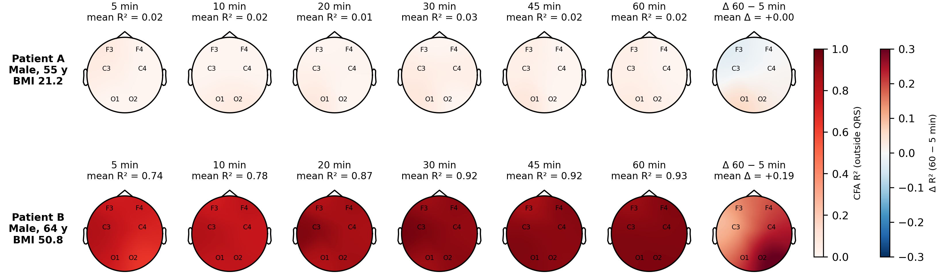
Figure 1. Cardiac field artifact (CFA) in two example patients. Each head map shows the per-channel CFA R² (variance of the R-peak-locked EEG average explained by the ECG average, outside the ±50 ms QRS window) at each recorded electrode, computed from segments of 5, 10, 20, 30, 45, and 60 min drawn from the same recording; the last column shows the change from 5 to 60 min. Patient A (male, 55 years, BMI 21.2 kg/m²) showed almost no CFA at any duration (mean R² 0.02–0.03). Patient B (male, 64 years, BMI 50.8 kg/m²) showed high CFA at every electrode, which increased from 0.74 at 5 min to 0.93 at 60 min. Colour maps are interpolated from 6 electrodes; electrode names mark the recording sites.
Figure 1 illustrates how much CFA can differ between people. In a lean man (Patient A, BMI 21.2 kg/m²), the ECG explained only 2% of the heartbeat-locked EEG variance at 10 min, and this value did not change with segment duration. In a man with severe obesity (Patient B, BMI 50.8 kg/m²), the ECG explained 78% at 10 min, so the heartbeat-locked EEG was almost a scaled copy of the ECG at every electrode. In Patient B, CFA also increased with segment duration, from 0.74 at 5 min to 0.93 at 60 min. The cohort-level analyses below test whether these patterns, higher CFA with higher BMI and with longer segments, hold across the population.

3.3 CFA across the cohort
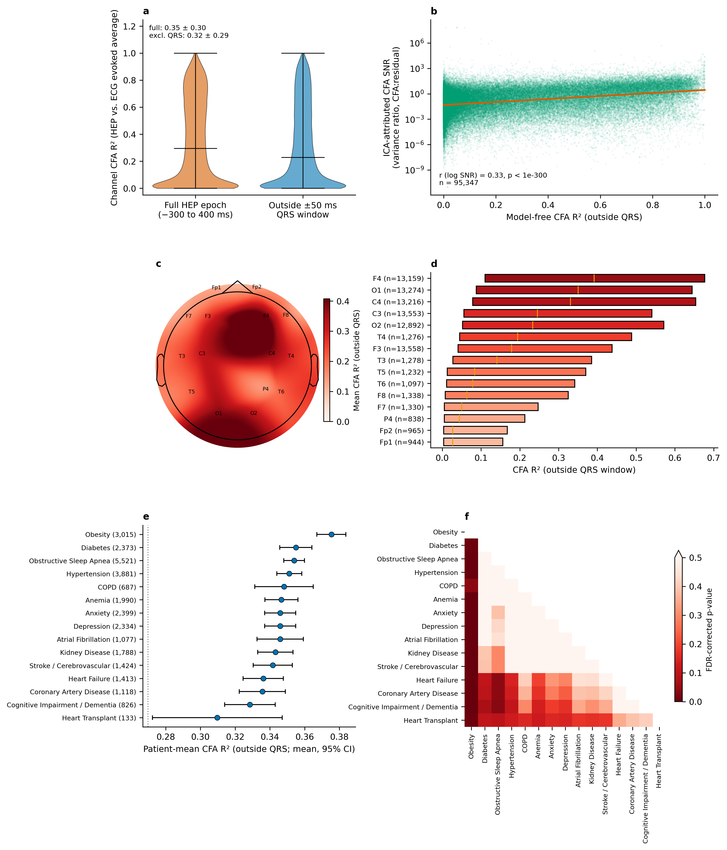
Figure 2. Cardiac field artifact (CFA) across 7,995 patients (98,203 channel-recordings, 10-min segments). (a) Model-free estimator: distribution of per-channel R² between the R-peak-locked EEG average and the ECG average, over the full epoch (mean 0.35) and outside the ±50 ms QRS-exclusion window (mean 0.32). (b) Model-based estimator (7,933 patients): ICA SNR (ECG-related component variance relative to residual variance; see Section 2.4) plotted against the model-free CFA R² of the same channel-recording (logarithmic SNR axis; line, least-squares fit of log SNR on R²; r = 0.33, p < 1e-300, n = 95,347). (c) Scalp map of mean CFA R² (outside QRS) at the 15 canonical 10-20 sites recorded in at least 500 patients (89,951 channel-recordings; bipolar/mastoid-referenced labels were canonicalised to their scalp-side site; Cz, Fz, Oz, P3, Pz were dropped for falling below the patient floor). (d) Distribution of per-channel R² per site, sorted by median (orange line); box, interquartile range; n per site is indicated. Coverage is uneven, from the six standard montage sites (F3/F4/C3/C4/O1/O2; n > 12,000 each) to sites near the 500-patient threshold, whose estimates are less precise. (e) Patient-mean CFA R² per clinical diagnosis category (mean, 95% CI, Welch; number of patients in brackets); dotted line, EHR-linked patients with no recorded diagnosis (mean 0.27, n = 500; confounded by recording site, see Limitations). Patients may belong to more than one category; categories are drawn from fifteen predefined groups, and those with fewer than 10 patients are omitted; Kruskal-Wallis test across all groups, p = 9.1e-21. (f) Pairwise comparisons among categories: Mann-Whitney p-values, Benjamini-Hochberg corrected across all 105 tests (17 pairs significant at q < 0.05; colour scale saturates at q = 0.5); categories ordered as in (e).
Across the cohort, the ECG explained a substantial proportion of heartbeat-locked EEG variance outside the conventional QRS-exclusion window (mean R² = 0.32, median 0.23; Figure 2a). This value was only modestly lower than the full-epoch estimate (mean R² = 0.35), so QRS exclusion removed only approximately 10% of the ECG-explained variance. The distribution was broad, from channels with no detectable CFA to channels in which the EEG average was almost identical to the ECG average. In the 148-patient subsample with a chance-level reference (see Section 2.6), full-epoch R² at some electrodes (F3, F4, C3, C4) was 0.35 for R-peak-locked averages but 0.04 (median 0.03) for averages around random pseudo-events, so the observed R² far exceeded chance similarity between finite-length averages.
The model-based estimator agreed. Across all channels, the ECG-related ICA component accounted for a median of 21% of heartbeat-locked EEG variance, and excluding it reduced this variance by a median of 28%. Channels with higher model-free R² also had higher ICA SNR (Figure 2b). The dispersion in Figure 2b is expected, because a single, globally selected ICA source does not load equally on all electrodes. Regression on the concurrently recorded ECG has previously been proposed for estimating and removing CFA from heartbeat-locked EEG, in linear²² and, more recently, nonlinear neural-network²³ form. Following this approach, we used the per-channel ECG regression as the primary estimate and the ICA-based removal as convergent evidence.
CFA was not uniformly distributed across the scalp (Figure 2c–d); it was highest at F4 (mean R² = 0.41) and lowest at Fp1 (mean R² = 0.12), an approximately 3.3-fold range. Because sites outside the standard montage came from a minority of recordings with different montages and references, part of this range reflects montage and referencing rather than electrode position; within the six standard, mastoid-referenced sites, mean R² ranged from 0.27 (F3) to 0.41 (F4). A site-independent CFA correction would therefore perform unevenly across electrodes.

3.4 CFA increases with BMI and is higher in men
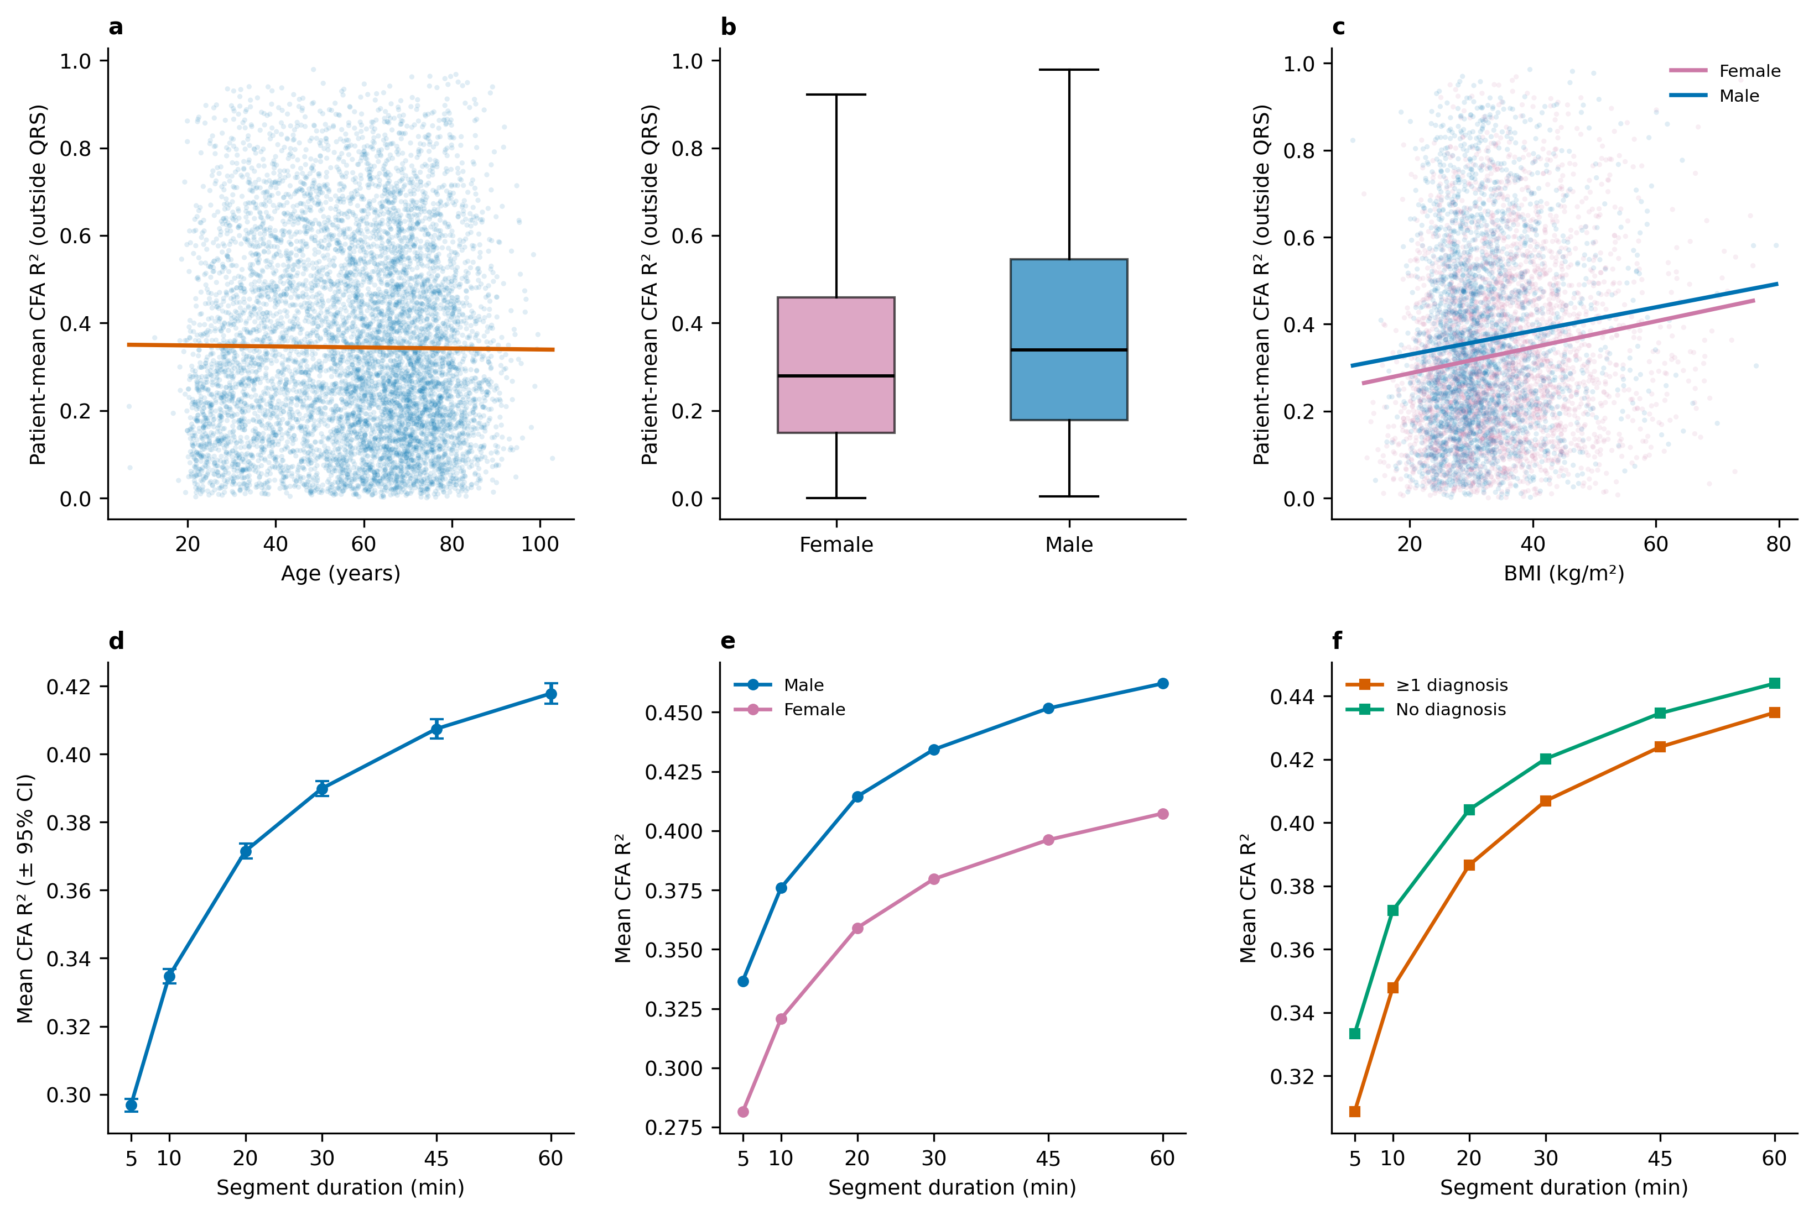
Figure 3. Dependence of CFA on patient characteristics (a–c) and segment duration (d–f). Patient-mean CFA R² (outside QRS) vs. (a) age, continuous (n = 7,729; Pearson r = -0.01, p = 0.41; line = least-squares fit), (b) sex (Mann-Whitney p = 1.5e-21; box shows quartiles; outliers omitted), and (c) BMI, continuous, with sex-specific fits (n = 6,127; Pearson r = 0.11, p = 4.3e-17; one observation per patient, longest available window; 5 min: n=48, 10 min: n=22, 20 min: n=72, 30 min: n=5,985). Female n = 3,354, r = 0.14, p = 4.0e-17; male n = 2,773, r = 0.09, p = 9.6e-07; BMI-by-sex interaction p = 0.67. (d–f) Patients with usable data at every duration (n = 7,079). (d) Mean channel-level CFA R² (all EEG channels; ± 95% CI) at each duration (5 min: 0.30; 10 min: 0.33; 20 min: 0.37; 30 min: 0.39; 45 min: 0.41; 60 min: 0.42); Friedman test across durations on patient-mean R², p < 1e-300; every consecutive step significant (paired Wilcoxon, Holm-corrected, all p ≤ 4e-74). (e) Sex-stratified estimates; men had higher CFA at every duration (Mann-Whitney, all p ≤ 1.94e-17). (f) Diagnosis-stratified estimates; differences were not significant (p = 0.06–0.59).
BMI was positively correlated with CFA R² (Figure 3c; n = 6,127, Pearson r = 0.11, p = 4.3e-17; mean BMI 33.5 kg/m²). Each 10 kg/m² increase in BMI was associated with an increase of 0.025 in patient-mean R². The correlation was positive and significant in both women (r = 0.14, p = 4.0e-17) and men (r = 0.09, p = 9.6e-07), and the BMI-by-sex interaction was not significant (p = 0.67). The association, although weak at the level of the individual (r² ≈ 0.01), was consistent with the diagnosis analysis, in which clinically obese patients had the highest CFA of all diagnosis categories (see Section 3.6).
Sex also had a clear effect. Patient-mean CFA R² was higher in men than in women (0.37 vs. 0.32, p = 1.5e-21; Figure 3b). This difference was not explained by BMI: women in this cohort had a higher mean BMI than men (34.8 vs. 31.8 kg/m²), and the male-versus-female coefficient was unchanged after adjustment for BMI (0.031 unadjusted vs. 0.040 adjusted, p = 3.2e-13; Supplementary Section S5), while BMI remained an independent predictor (p = 1.5e-21). The sex difference was also present at every segment duration (see Section 3.5). In contrast, age showed no linear relationship with CFA R² (Figure 3a; r = -0.01, p = 0.41); only the oldest age tertile was slightly lower than the younger two (0.33 vs. 0.35/0.35, p = 1.0e-04).

3.5 Segment duration changes the estimated CFA
Segment duration had a significant and systematic effect on the estimated CFA (Friedman χ² = 8,237, p < 1e-300, Kendall's W = 0.23; n = 7,079). Mean CFA R² increased from 0.30 at 5 min to 0.33 at 10 min, 0.37 at 20 min, 0.39 at 30 min, 0.41 at 45 min, and 0.42 at 60 min (Figure 3d), and every consecutive step was significant after Holm correction. Between 5 and 60 min, R² increased in 79% of patients (mean increase 0.12); between the 10-min windows of the main analysis and 60 min, it increased in 74% of patients (mean increase 0.09). The gain per step decreased with duration, from 0.04 R² units between 10 and 20 min to 0.01 between 45 and 60 min, but no plateau was reached within 60 min. Fewer channel-recordings contributed at 45 and 60 min (46,099 vs. 79,304 at 30 min), so the longest-window means may partly reflect a different channel composition; between 5 and 30 min, however, channel composition was nearly constant (79,651 to 79,304 channel-recordings), and R² still increased monotonically.
The sex difference was stable across durations: men had higher CFA than women at every duration (Figure 3e; e.g. 0.34 vs. 0.28 at 5 min and 0.46 vs. 0.41 at 60 min). Diagnosis differences were not significant in this matched subset (Figure 3f), and the no-diagnosis mean was numerically higher than the any-diagnosis mean at every duration, consistent with the within-site reversal described in the Limitations.

3.6 CFA by diagnosis category
Among diagnosis categories (Figure 2e–f), CFA was highest in patients with Obesity (+0.11 R² units relative to the no-diagnosis reference, n = 3,015) and lowest in Heart Transplant (+0.04, n = 133). Of 105 pairwise comparisons between categories, 17 remained significant after FDR correction, of which 14 involved Obesity, which differed significantly from every other category; the remainder involved Obstructive Sleep Apnea. This pattern agrees with the BMI association (see Section 3.4). All 15 displayed categories lay above the no-diagnosis reference, but because the reference group is confounded by recording site (see Limitations) and the comparisons were unadjusted for age, sex, and BMI, these differences should not be interpreted as disease effects.

3.7 ECG-free cleaning with a cohort-trained spatial filter
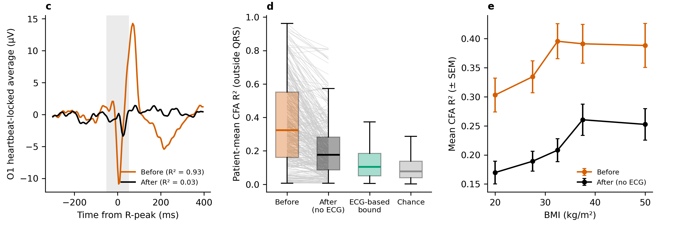
Figure 4. ECG-free cleaning of CFA with a spatial filter learned from the cohort (see Section 2.8). (a) Six seconds of EEG from Patient B (Figure 1) before (orange) and after (black) cleaning; the ECG (*) is shown for reference only and was not used; dotted lines mark R-peaks. (b) Population CFA pattern learned from 500 training patients. (c) Heartbeat-locked average of Patient B at the channel with the largest reduction, before and after cleaning (grey band, ±50 ms QRS window). (d) Patient-mean CFA R² in 319 held-out patients before and after ECG-free cleaning, compared with an upper bound that uses each patient's own ECG and with the pseudo-event chance level; grey lines connect the same patient. (e) Mean CFA R² (± SEM) before and after cleaning across BMI bins (bins with at least 10 patients).
The CFA scalp pattern was highly consistent across patients (median absolute cosine similarity between individual patterns and the population pattern, 0.89; Figure 4b). Projecting this single learned pattern out of held-out recordings, with no ECG, reduced mean CFA R² from 0.37 to 0.21 (a 42% reduction; Wilcoxon p = 6.8e-36), and R² decreased in 76% of patients (Figure 4d). The ECG-based upper bound reached 0.13 and the chance level was 0.10, so the ECG-free filter closed 66% of the gap between uncleaned data and the upper bound. In Patient B, mean R² fell from 0.91 to 0.61, and the heartbeat-locked deflections visible in the raw EEG were largely removed (Figure 4a, c). Cleaning reduced CFA at every BMI level, although residual CFA remained higher at higher BMI (Figure 4e). Patterns learned separately by sex and BMI group gave a small further gain (mean R² 0.20 vs. 0.21; p = 0.0089), consistent with BMI and sex mainly changing the amount of CFA rather than its scalp pattern. The cleaning retained a median of 80% of an injected synthetic neural HEP and changed ongoing EEG power by a median of -1.3 dB (1–40 Hz), the cost of removing one of six spatial dimensions.

4. Discussion
In 7,995 patients, by far the largest sample in which the cardiac field artifact has been measured, two complementary estimators showed that a substantial proportion of heartbeat-locked scalp EEG variance is shared with the ECG even after standard QRS exclusion. The sample size allowed us to move beyond describing CFA as a generic nuisance and to show that it is a variable property of each person and each analysis: it ranged from negligible to near-complete between individual patients (Figure 1), varied approximately 3.3-fold across scalp sites (Figure 2c–d), increased with BMI, was higher in men than in women (Figure 3a–c), and depended strongly on segment duration (Figure 3d–f). These factors are common grouping variables or analysis choices in EEG research, so uncorrected CFA can create, mask, or inflate group differences in heartbeat-locked EEG measures.
Although CFA is most prominent around the QRS complex, the conventional ±30–50 ms exclusion⁶⁻⁸ did not remove it: excluding ±50 ms reduced mean ECG-shared variance (R²) only from 0.35 to 0.32, so a substantial ECG-correlated component extends into the nominal analysis interval. The positive relationship between the model-free R² and the ICA-derived SNR indicates that both methods detect the same contamination. Neither estimator establishes that every residual heartbeat-locked deflection is artifactual, and genuine cortical heartbeat-evoked activity is well documented^{5,6,10}. Nevertheless, uncorrected heartbeat-locked EEG variance cannot be assumed to be of cortical origin.
BMI was positively correlated with CFA, in women and in men, and clinically obese patients had the highest CFA of all diagnosis categories, differing significantly from every other category. The two examples in Figure 1 illustrate the extremes: almost no CFA in a lean man and near-complete CFA in a man with severe obesity. At first sight this is counterintuitive: adipose tissue is a poor electrical conductor, with a conductivity roughly an order of magnitude lower than that of muscle²⁴, and subcutaneous fat attenuates the surface ECG, so that obesity is associated with low QRS voltage^{12,13}. If fat acted only as an insulating layer, the cardiac field reaching the scalp should be smaller, not larger. The resolution lies in what R² measures. R² is scale-invariant: it indexes how closely the shape of the heartbeat-locked scalp average follows the shape of the ECG, not the amplitude of either. A uniform attenuation of the cardiac field would scale the CFA waveform (and the ECG lead itself) without changing their correlation. R² increases only when the cardiac component grows relative to everything else in the heartbeat-locked average, that is, relative to residual background EEG and genuine neural responses. Several physical changes in obesity could increase this relative share. First, obesity is associated with increased left-ventricular mass and a leftward, more horizontal electrical axis of the heart¹³, which change the strength and orientation of the cardiac dipole relative to the head; in the mastoid-referenced derivations used here, CFA reflects the difference in cardiac potential between the scalp electrode and the mastoid, which depends strongly on dipole orientation. Second, low-conductivity tissue does not only attenuate volume currents but also redistributes them, so a thick insulating layer around the thorax and neck may change which fraction of the cardiac field projects onto the head. Third, tissue between the brain and the electrode attenuates cortical EEG at the same electrode. A trivial explanation, more heartbeats per window, is unlikely: heart rate was slightly lower at higher BMI (r = -0.07), and adjusting for heart rate did not reduce the BMI coefficient (0.0024 unadjusted vs. 0.0025 adjusted per kg/m², n = 5,985). Which of these mechanisms dominates cannot be determined from the present data; an analysis of absolute CFA amplitude, which would be expected to decrease with BMI if insulation dominated, and direct measures of body composition and heart position would be needed. At the level of the individual, the correlation was weak (r = 0.11), so BMI alone cannot predict how much CFA a given recording contains; at the level of the group, however, a difference in mean BMI between study groups, which is common in clinical comparisons, will translate into a systematic difference in CFA.
Sex had a robust effect: CFA was higher in men than in women, at every segment duration, and the difference was unchanged after adjustment for BMI. Because women in this cohort had a higher mean BMI, BMI would, if anything, have reduced the sex difference. The sex effect may reflect differences in heart size and position, thoracic and head geometry, or body-fat distribution, none of which were measured here; cardiac parameters such as stroke volume have been proposed to influence heartbeat-locked responses¹¹. Whatever its origin, sex differences are among the most frequently reported group effects in EEG research, and studies that compare men and women on heartbeat-locked measures should therefore quantify CFA per channel and show that the difference survives its correction.
Segment duration had the largest and most consistent effect. In the duration-matched 7,079-patient analysis, mean R² rose from 0.30 at 5 min and 0.33 at 10 min to 0.42 at 60 min, every step was significant, and R² increased between 5 and 60 min in 79% of patients. Longer segments contain more heartbeats and yield a more stable heartbeat-locked average¹⁴, which allows shared EEG-ECG structure to emerge from background EEG. The practical consequences are twofold. First, short segments, including the 10-min segments of our main analysis, underestimate CFA, so a low CFA estimate from a short recording does not show that the data are clean. Second, studies or groups that differ in recording length, or in the number of usable heartbeats, will differ in apparent CFA for purely methodological reasons. The segment length is therefore not a neutral analysis parameter: it should be reported, justified, and, where possible, matched between groups, and the stability of results should be checked across durations. Because R² depends on the number of averaged heartbeats, between-group differences in heart rate could also contribute to differences in R²; this was not examined in the present analysis.
BMI is an anthropometric index rather than a direct measure of adiposity; no direct measures of fat mass, thoracic geometry, or electrode impedance were available, and diagnosis categories overlap. We therefore interpret these findings as evidence that BMI, clinical obesity, and sex are confounders of CFA, not as evidence of a causal effect of body fat. Likewise, the associations of age and diagnosis category with CFA may reflect anatomy, cardiac physiology, medication, comorbidity, or recording conditions.
In practice, EEG preprocessing should combine concurrent ECG recording, channel-level assessment of the R-peak-locked EEG-ECG relationship, and removal or regression of ECG-related components, followed by verification that heartbeat-locked variance in the cleaned signal is reduced relative to the uncleaned data while remaining above a non-heartbeat-locked noise floor. Reporting only the QRS mask or the selected ICA component is insufficient. We recommend that studies report the segment duration and number of heartbeats, match them between groups where possible, report channel-level CFA metrics before and after cleaning, and test whether results are robust to adjustment for BMI (or, preferably, direct body-composition measures) and sex. These recommendations extend recent methodological reviews of HEP analysis and reporting^{8,9} to EEG analyses more generally.
For recordings without ECG, the proof of concept in Section 3.7 suggests a practical route: because the scalp pattern of CFA is consistent across people, a spatial filter learned from a large cohort with ECG removed about 42% of CFA in new patients without any cardiac reference. The filter is specific to the montage and reference on which it was trained, it removes one spatial dimension of the EEG, and it does not remove all CFA. It should therefore be validated on other montages, and it is best regarded as a first step towards a trained tool that combines learned cardiac patterns with information about the participant, such as BMI and sex, and the recording length.

5. Conclusions
In 7,995 patients, cardiac field artifact was a substantial and systematic component of scalp EEG^{1,2}, consistent with its long-recognised role as an EEG artifact^{3,4}: the ECG explained a mean R² of 0.32 of heartbeat-locked EEG variance outside the QRS-exclusion window, and ICA-based removal of the ECG-related component reduced this variance by a median of 28%. CFA increased with BMI, was higher in men than in women independently of BMI, varied across electrodes, and increased significantly with segment duration up to the longest window examined (60 min). CFA should therefore be treated as a participant-, channel-, and duration-dependent source of noise in EEG. Robust inference requires ECG-informed channel-level cleaning with quantitative before-and-after validation^{8,9}, reported and justified segment lengths¹⁴, and adjustment for BMI and sex. Without these safeguards, apparent group differences in EEG may partly reflect the electrical field of the heart rather than brain activity^{6,11}.

Limitations
Several limitations should be noted. First, diagnosis records were available for only part of the Human Sleep Project, so the no-diagnosis reference group consisted largely of patients from a site without linked diagnosis tables (mean R² 0.19, n = 319). Within the site with diagnosis records, patients without a recorded diagnosis had higher R² than those with one (0.41, n = 181, vs. 0.35, n = 7,229). The comparison of patients with and without a linked diagnosis is therefore confounded by recording site and should not be interpreted as a disease effect; comparisons among diagnosis categories are not affected by this confound. Second, the detected heart rate was high for sleep recordings (median 94 beats/min, interquartile range 78–111); the custom R-peak detector was not validated against an established algorithm, and occasional detection of T waves would mix T-wave-locked epochs into the averages. Third, R² does not distinguish volume-conducted CFA from neural activity whose time course resembles the ECG, and epochs ended at 400 ms after the R-peak, so the estimates do not cover later HEP intervals that overlap the T wave. Fourth, CFA was estimated in the native recording references, predominantly contralateral-mastoid derivations (e.g., F3-M2, F4-M1); because the cardiac field projects differently onto each reference electrode, site-level values and hemispheric asymmetries may not generalise to average-referenced HEP data.
Fifth, 10-min estimates are likely lower bounds with respect to segment duration, because mean CFA R² increased monotonically with duration, including from 5 to 30 min, where channel composition was nearly constant (see Section 3.5). Sixth, the chance-level (pseudo-event) R² was estimated only in a subsample of 148 patients and only over the full epoch (see Section 3.3); a null for the outside-QRS estimate was not computed. Seventh, windows were not selected by sleep stage, so vigilance state was not controlled and may differ between groups and segment durations; CFA did not differ between stages in a staged subsample, but that subsample was small (n = 23; see Section 3.1). Eighth, the cohort was predominantly a clinically referred population with a high diagnostic burden (Figure S1c), which limits the generalisability of absolute R² values to healthy volunteers; underweight patients were also under-represented (55 of 6,127 patients with measured BMI had a BMI <18.5 kg/m²). Finally, because this was a secondary analysis of existing datasets, recording parameters and clinical annotations could not be controlled by the authors.

Ethics statement
Human Sleep Project data were de-identified under the HIPAA Safe Harbor standard and made available under an approved institutional review board protocol (IRB protocol #2022P000417) with a waiver of informed consent; they were accessed under the Brain Data Science Platform data use agreement. No attempt was made to re-identify participants.

Data availability statement
The Human Sleep Project dataset is publicly available, subject to a data use agreement, from the Brain Data Science Platform (https://bdsp.io/content/hsp/). Analysis code is available from the corresponding author upon reasonable request (nircafri@mail.tau.ac.il).

Funding

Declaration of competing interests
The authors declare no competing interests.

Supplementary analysis

S1. Cohort composition
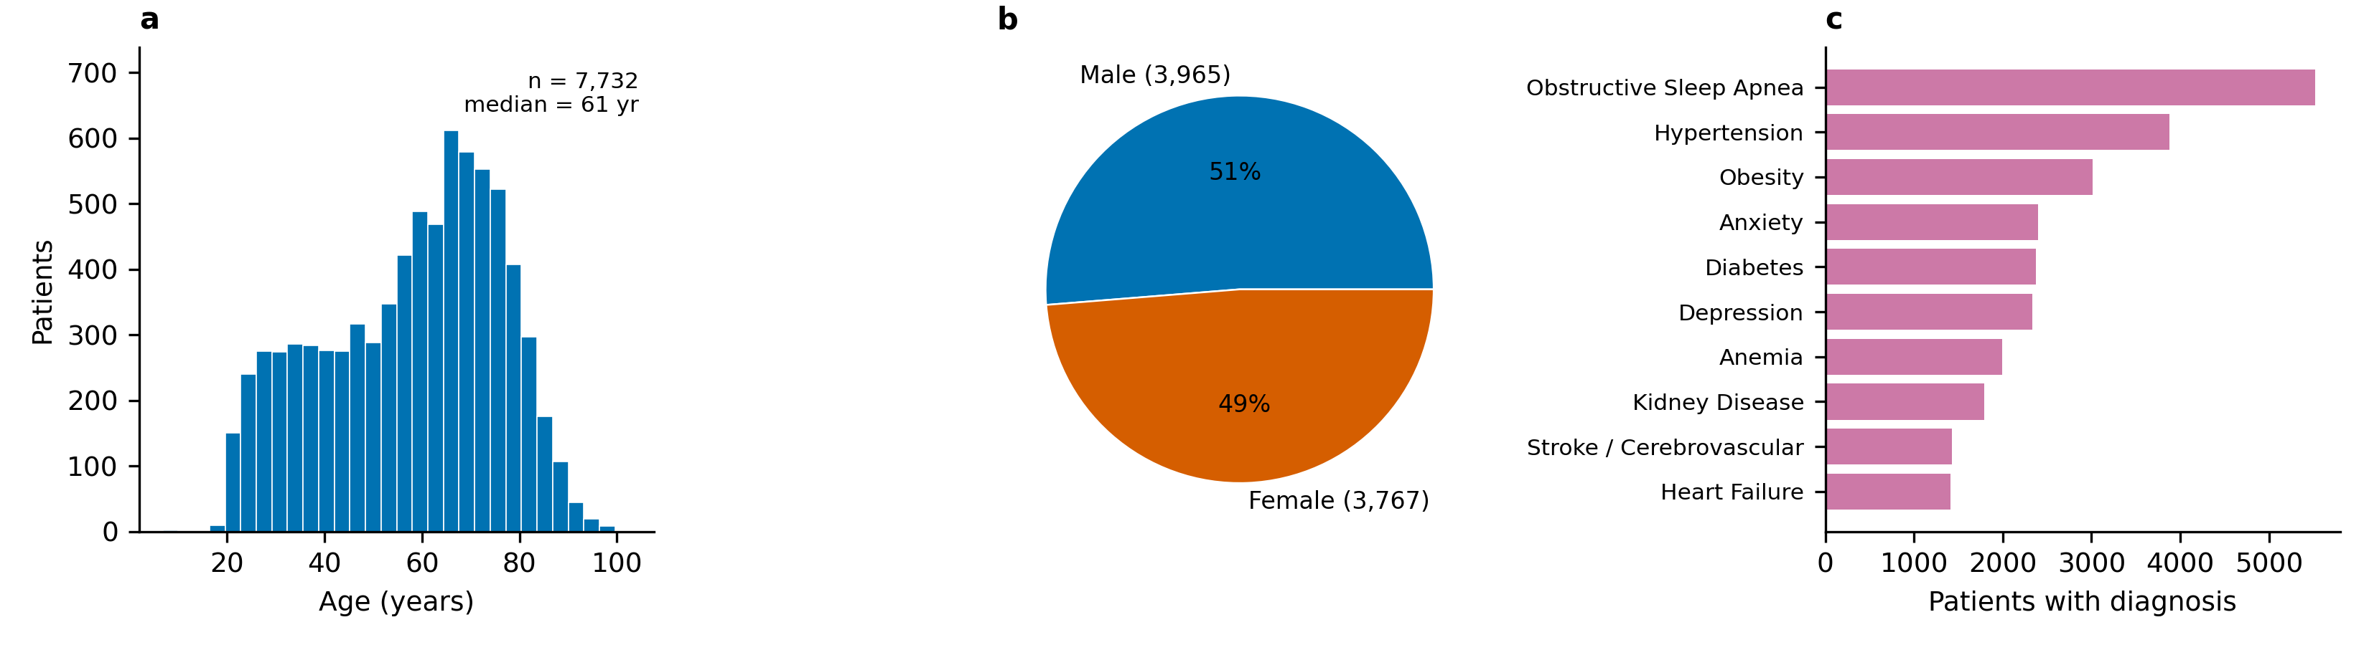
Figure S1. Cohort composition of the 7,738 Human Sleep Project patients. (a) Age distribution (median 61 years, range 7–103). (b) Sex (Male n=3,965, Female n=3,767). (c) The ten most prevalent clinical diagnosis categories, the largest of which were Obstructive Sleep Apnea (n=5,524); Hypertension (n=3,882); Obesity (n=3,016). The cohort is a clinically referred polysomnography population rather than a healthy community sample; diagnosis categories are not mutually exclusive.
Table S1. Diagnosis categories and the case-insensitive keywords matched against EHR diagnosis descriptions. Keyword matching is inclusive; for example, "infarction" also matches myocardial infarction.
Category | Keywords (any match)
Obstructive Sleep Apnea | sleep apnea
Hypertension | hypertension
Diabetes | diabetes
Heart Failure | heart failure
Coronary Artery Disease | coronary; atherosclerotic heart
Heart Transplant | heart transplant; transplant status
Atrial Fibrillation | atrial fibrillation; atrial flutter
COPD | chronic obstructive
Obesity | obesity; obese
Depression | depressive; depression
Anxiety | anxiety
Cognitive Impairment / Dementia | cognitive; alzheimer; dementia
Stroke / Cerebrovascular | infarction; cerebrovascular; stroke; hemorrhage
Kidney Disease | kidney; renal
Anemia | anemia

S2. Variance and entropy vs. a non-heartbeat-locked noise floor
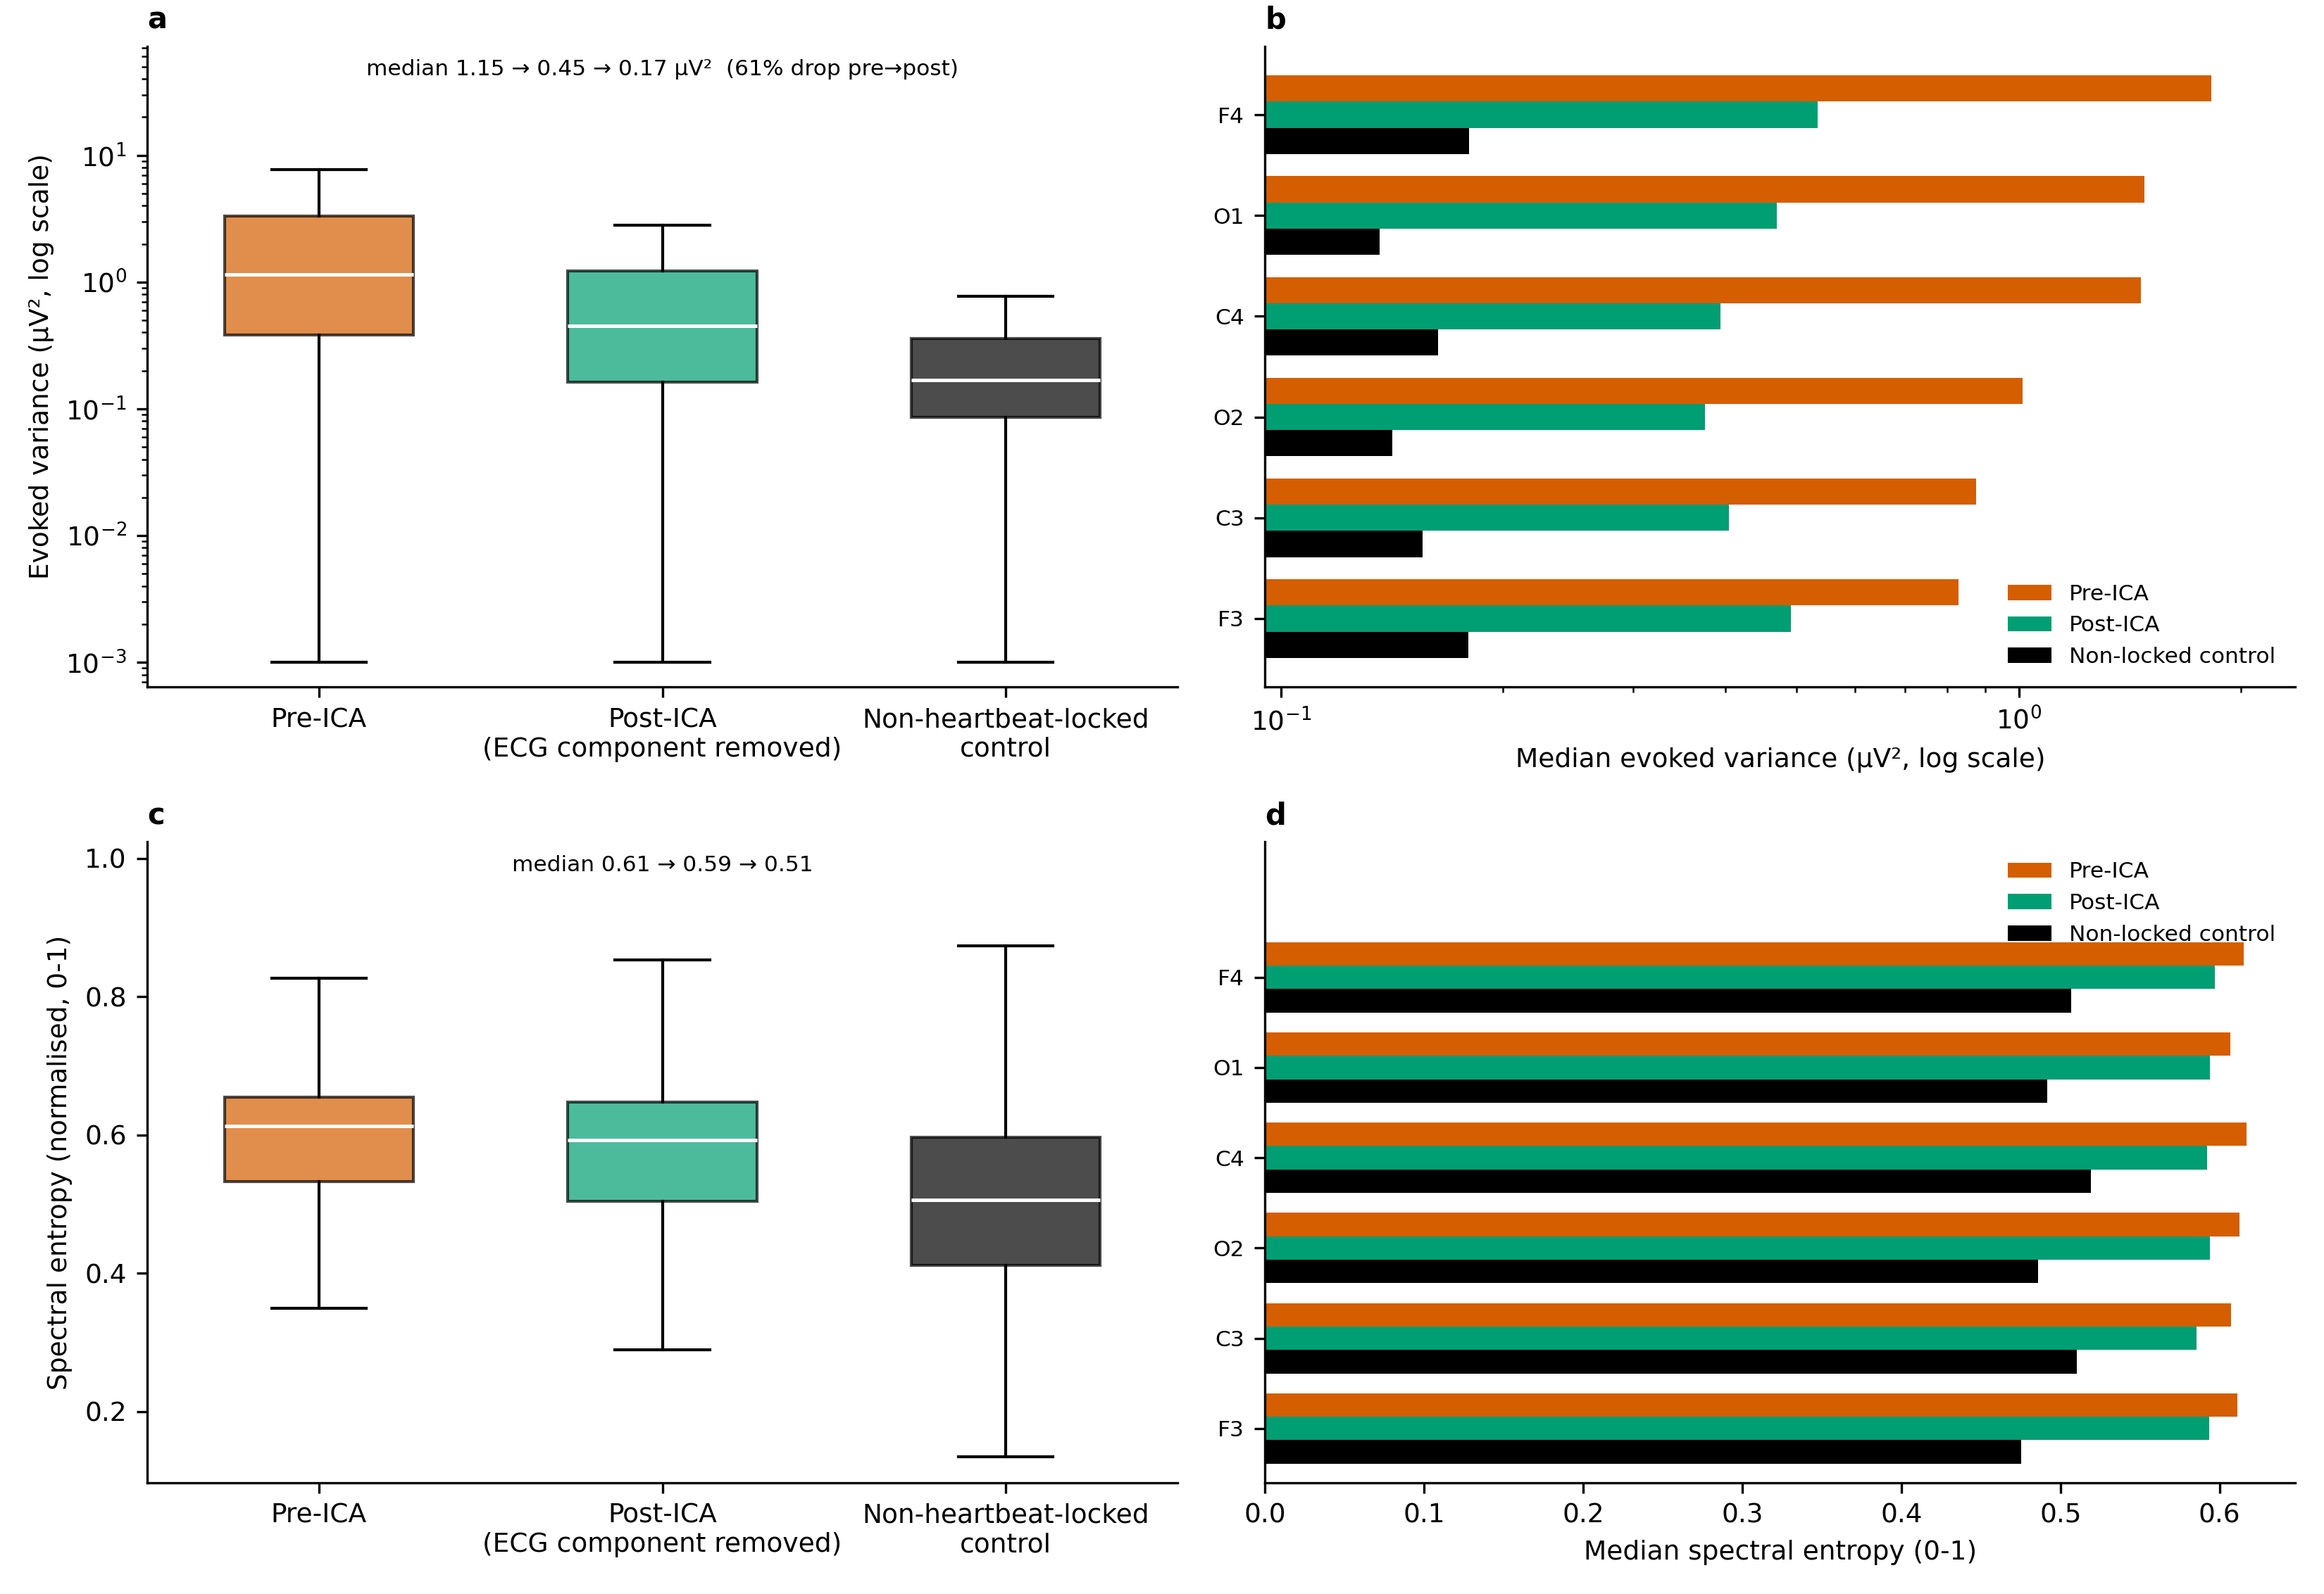
Figure S2. Absolute HEP variance before vs. after excluding the ECG-related ICA component, alongside a non-heartbeat-locked control (n = 7,851 ICA patients with at least one well-covered site; 973-patient control subsample, Section 2.6; medians on a log axis are reported rather than means). (a) Pooled over channels at the four core frontal-central electrodes (F3/F4/C3/C4): median 1.15 µV² pre-ICA to 0.45 µV² post-ICA (a 61% drop) vs. 0.17 µV² for the non-locked control (the same windows re-epoched around random pseudo-events instead of R-peaks). (b) The same three-way comparison broken out per electrode, all six sites (see Section 2.5). (c) Spectral entropy (normalised Shannon entropy of the evoked waveform's Welch power spectrum, 0–1) of the same three conditions, core electrode average (n = 492 patients, separate subsample). (d) Spectral entropy per electrode.
Removal of the ECG-related component reduced median core-electrode HEP variance by 61%; this ratio of group medians is larger than, and not directly comparable to, the median per-channel reduction reported in Section 3.3 (28%). The non-heartbeat-locked control defines the finite-sample noise floor (0.17 µV²), which was well below both the pre-ICA (1.15 µV²) and post-ICA (0.45 µV²) values. Both conditions therefore retained R-peak-locked structure; post-ICA variance remained above the noise floor at every electrode (panel S2b), indicating that component removal did not reduce the heartbeat-locked signal to noise level. Spectral entropy provided a complementary, variance-independent measure: entropy decreased from pre-ICA (0.61) to post-ICA (0.59) to the non-locked control (0.51); the post-ICA decrease was small, and post-ICA values exceeded the control at every electrode (panel S2d).

S3. EEG-ECG cross-correlation and mutual information
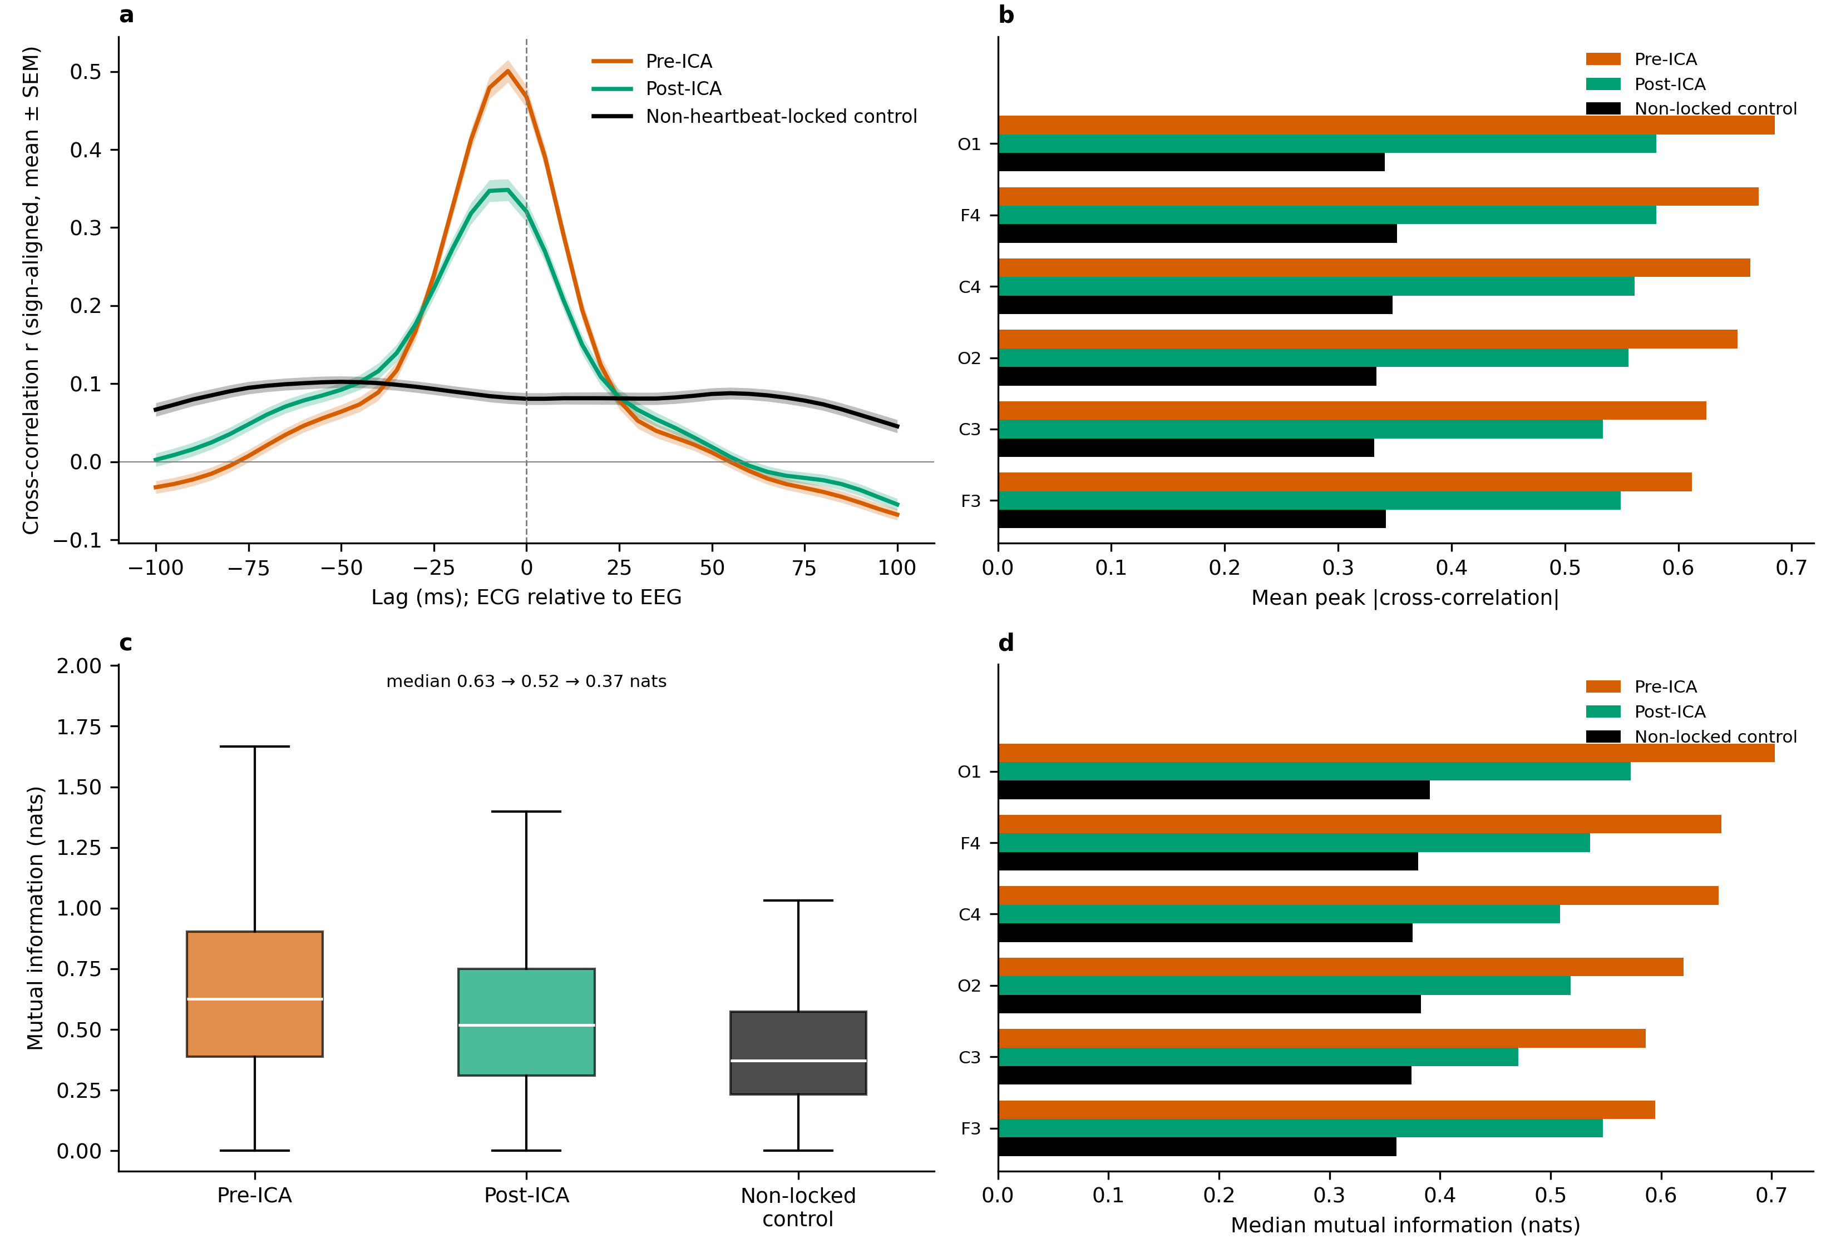
Figure S3. EEG-ECG cross-correlation and mutual information for pre-ICA, post-ICA, and non-heartbeat-locked control conditions (n = 148 patients; separate subsample in which ICA was refitted to obtain paired evoked waveforms; see Section 2.6). In the control condition, the same pre-ICA EEG was re-epoched around random pseudo-events and correlated with the R-peak-locked ECG evoked average, providing the chance-level relationship expected in the absence of R-peak-locked structure. (a) Lag-resolved cross-correlation between the core-electrode (F3/F4/C3/C4) HEP evoked average and the concurrent ECG evoked average, sign-aligned per channel before averaging; mean ± SEM across patients. (b) Mean peak |cross-correlation| (maximum over lags) per electrode for all three conditions. (c) Mutual information between the same waveform pairs, core-electrode average. (d) Mutual information per electrode.
Cross-correlation peaked near zero lag in both heartbeat-locked conditions (median peak lag -5 ms pre-ICA and -10 ms post-ICA), consistent with the near-instantaneous volume conduction assumed by the zero-lag regression estimator (see Section 2.3). Peak correlation decreased from pre-ICA (mean |r| = 0.64) to post-ICA (mean |r| = 0.56) to the non-locked control (mean |r| = 0.34), and mutual information decreased correspondingly, from 0.63 to 0.52 to 0.37 nats (panel c). Post-ICA values remained above the non-locked floor at every well-covered electrode (panels S3b, S3d), indicating that a non-trivial EEG-ECG relationship persists after cleaning, in agreement with Section 3.3 and Supplementary Figure S2. Mutual information, which is also sensitive to nonlinear dependence, followed the same ordering as peak correlation, giving no indication of substantial EEG-ECG dependence beyond that captured by the linear measures of Section 3.3.

S4. Power spectral density: pre-ICA, post-ICA, non-locked control, and ECG
To complement the correlation- and variance-based summaries, we compared the spectral content of each evoked waveform. Welch power spectral density was computed for the pre-ICA, post-ICA, and non-locked evoked waveforms described in Section S3 and for the patient’s ECG evoked average, in the same 150-patient subsample.
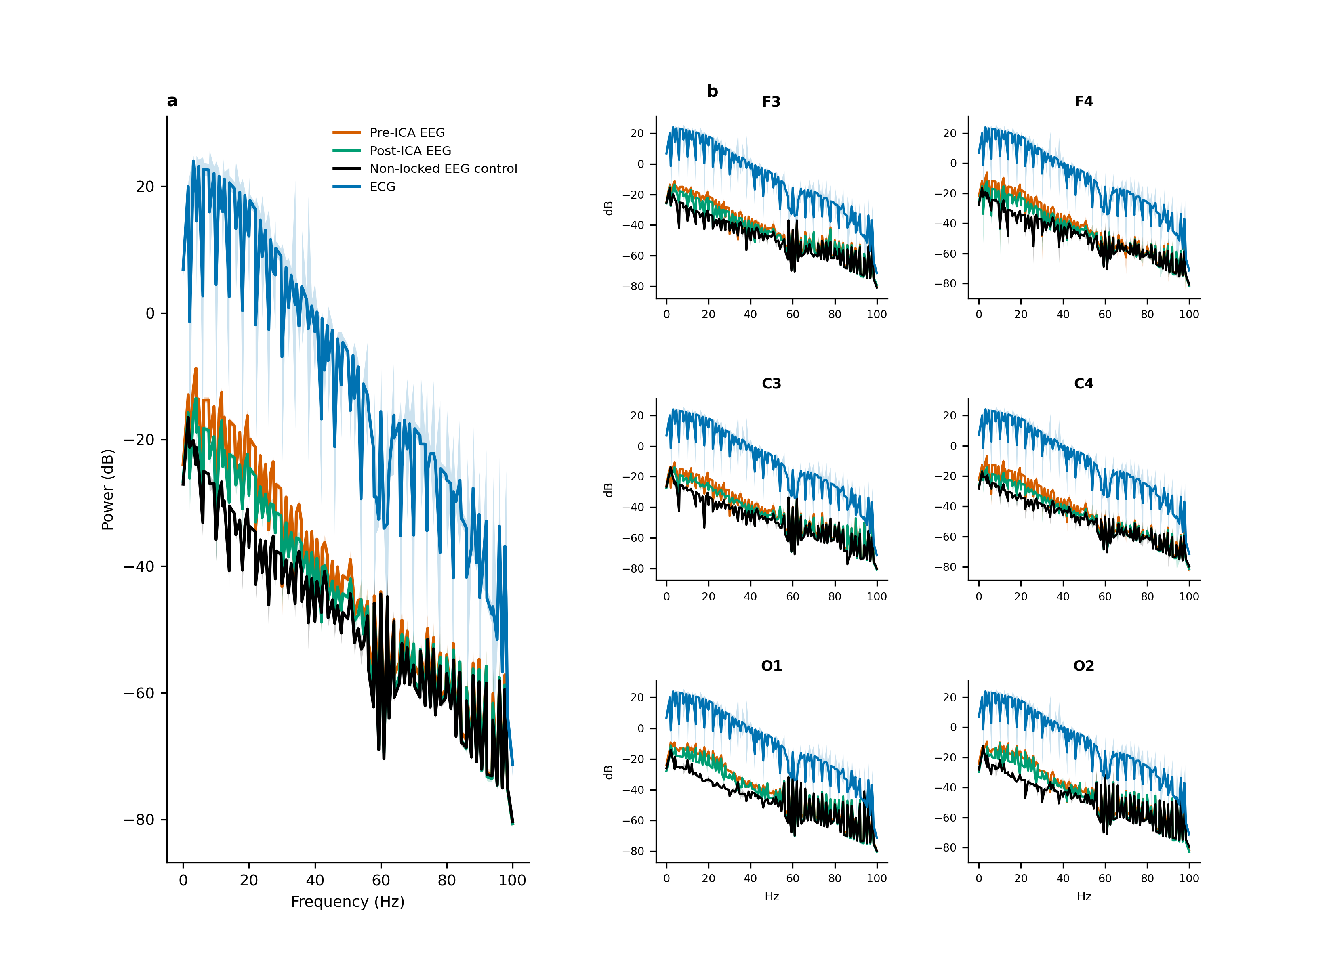
Figure S4. Power spectral density (Welch, dB) of the pre-ICA, post-ICA, non-heartbeat-locked control, and ECG evoked waveforms (n = 150 patients). (a) Group average: core four-electrode (F3/F4/C3/C4) average, all four conditions overlaid (mean ± SEM). (b) Per-electrode: the same four-way overlay for each of the six well-covered sites (see Section 2.5).
The ECG spectrum was broadband and structured, dominated by the sharp QRS transient, whereas the non-locked EEG control lacked this QRS-dominated structure. Pre-ICA and post-ICA EEG spectra lay between these two references and appeared visually closer to the ECG than the non-locked floor did, providing spectral-domain support for the conclusions of Section 3.3 and Section S3. Spectral shape was visually similar across the six electrodes (panel b), suggesting that CFA varies across the scalp mainly in magnitude (Figure 2c) rather than in spectral content. Spectra are shown up to 100 Hz, the upper edge of the analysis band-pass filter (see Section 2.2).

S5. Adjustment of the sex effect for BMI
Male patients had higher CFA R² than female patients (see Section 3.4), whereas mean BMI was higher in female patients (34.8 vs. 31.8 kg/m²); because BMI was itself associated with CFA, the sex comparison could be confounded by BMI. In the subsample with available BMI (n = 6,127), an OLS regression of patient-mean CFA R² (outside QRS) on sex alone yielded a male-versus-female coefficient of 0.031 (95% CI 0.020 to 0.041, p = 1.1e-08). Inclusion of BMI as a covariate did not attenuate the sex coefficient (0.040; 95% CI 0.029 to 0.050, p = 3.2e-13), while BMI itself was an independent, significant predictor (coefficient 0.0029 per BMI unit, p = 1.5e-21).
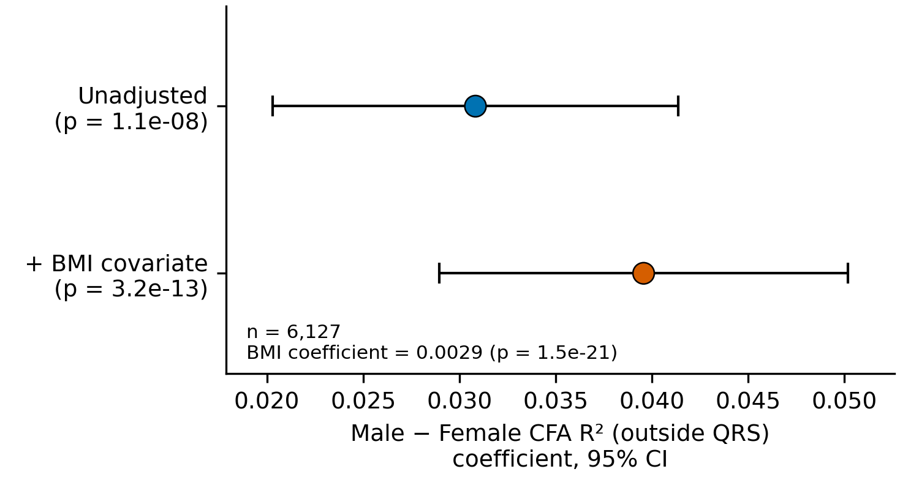
Figure S5. Male-versus-female CFA R² (outside QRS) OLS coefficient, unadjusted vs. BMI-adjusted, same BMI-available subsample (n = 6,127); points = coefficient, error bars = 95% CI.
The sex coefficient did not decrease after adjustment for BMI and, if anything, increased slightly, as expected given the higher BMI of female patients, arguing against BMI as the explanation for the sex effect observed in the full cohort. In this observational model, sex and BMI were thus independently associated with CFA.

Acknowledgements
The Human Sleep Project has received support from the Glenn Foundation and the American Federation of Aging Research (AFAR) through the 2018 Glenn / AFAR Award for Medical Research Breakthroughs in Gerontology (BIG) (2018), the American Academy of Sleep Medicine (AASM) through a 2019 Strategic Research Award, the National Institutes of Health (NIH) (R01NS102190, R01NS102574, R01NS107291, RF1AG064312, RF1NS120947, R01AG073410, R01HL161253, R01NS126282, R01AG073598), the National Science Foundation (NSF 2014431), and through the Henry and Allison McCance Center for Brain Health.

References
1. Dirlich G, Vogl L, Plaschke M, Strian F. Cardiac field effects on the EEG. Electroencephalogr Clin Neurophysiol. 1997;102(4):307-315.
2. Dirlich G, Dietl T, Vogl L, Strian F. Topography and morphology of heart action-related EEG potentials. Electroencephalogr Clin Neurophysiol. 1998;108(3):299-305.
3. Urigüen JA, Garcia-Zapirain B. EEG artifact removal—state-of-the-art and guidelines. J Neural Eng. 2015;12(3):031001. doi:10.1088/1741-2560/12/3/031001.
4. Jiang X, Bian G-B, Tian Z. Removal of artifacts from EEG signals: a review. Sensors. 2019;19(5):987. doi:10.3390/s19050987.
5. Schandry R, Sparrer B, Weitkunat R. From the heart to the brain: a study of heartbeat contingent scalp potentials. Int J Neurosci. 1986;30:261-275.
6. Park H-D, Blanke O. Heartbeat-evoked cortical responses: underlying mechanisms, functional roles, and methodological considerations. NeuroImage. 2019;197:502-511.
7. Coll M-P, Hobson H, Bird G, Murphy J. Systematic review and meta-analysis of the relationship between the heartbeat-evoked potential and interoception. Neurosci Biobehav Rev. 2021;122:190-200.
8. Steinfath TP, et al. Heartbeat-evoked responses in M/EEG: a systematic review of methods with suggestions for analysis and reporting. Psychophysiology. 2026;63(4):e70297. doi:10.1111/psyp.70297.
9. Virjee R-I, Kandasamy R, Garfinkel SN, Carmichael DW, Yogarajah M. Review of methods to derive the heartbeat-evoked potential: past practices and future directions. Soc Cogn Affect Neurosci. 2026:nsag057. doi:10.1093/scan/nsag057.
10. Kern M, Aertsen A, Schulze-Bonhage A, Ball T. Heart cycle-related effects on event-related potentials, spectral power changes, and connectivity patterns in the human ECoG. NeuroImage. 2013;81:178-190.
11. Buot A, Azzalini D, Chaumon M, Tallon-Baudry C. Does stroke volume influence heartbeat evoked responses? Biol Psychol. 2021;165:108165. doi:10.1016/j.biopsycho.2021.108165.
12. Tochikubo O, Miyajima E, Shigemasa T, Ishii M. Relation between body fat-corrected ECG voltage and ambulatory blood pressure in patients with essential hypertension. Hypertension. 1999;33(5):1159-1163. doi:10.1161/01.HYP.33.5.1159.
13. Fraley MA, Birchem JA, Senkottaiyan N, Alpert MA. Obesity and the electrocardiogram. Obes Rev. 2005;6(4):275-281.
14. Boudewyn MA, Luck SJ, Farrens JL, Kappenman ES. How many trials does it take to get a significant ERP effect? It depends. Psychophysiology. 2018;55(6):e13049.
15. Li Q, Wen S, Sun H, Ganglberger W, Tripathi A, Turley N, et al.; Westover MB. The Human Sleep Project (HSP). Brain Data Science Platform. 2026. doi:10.60508/m3sw-rz13.
16. Gramfort A, et al. MEG and EEG data analysis with MNE-Python. Front Neurosci. 2013;7:267.
17. Hyvarinen A, Oja E. Independent component analysis: algorithms and applications. Neural Netw. 2000;13(4-5):411-430.
18. Ablin P, Cardoso J-F, Gramfort A. Faster independent component analysis by preconditioning with Hessian approximations. IEEE Trans Signal Process. 2018;66(15):4040-4049.
19. Kraskov A, Stögbauer H, Grassberger P. Estimating mutual information. Phys Rev E. 2004;69(6):066138.
20. Benjamini Y, Hochberg Y. Controlling the false discovery rate: a practical and powerful approach to multiple testing. J R Stat Soc Series B. 1995;57(1):289-300.
21. Vallat R, Walker MP. An open-source, high-performance tool for automated sleep staging. eLife. 2021;10:e70092. doi:10.7554/eLife.70092.
22. Pérez JJ, Guijarro E, Barcia JA. Suppression of the cardiac electric field artifact from the heart action evoked potential. Med Biol Eng Comput. 2005;43(5):572-581.
23. Arnau S, Sharifian F, Wascher E, Larra MF. Removing the cardiac field artefact from the EEG using neural network regression. Psychophysiology. 2023:e14323. doi:10.1111/psyp.14323.
24. Gabriel S, Lau RW, Gabriel C. The dielectric properties of biological tissues: II. Measurements in the frequency range 10 Hz to 20 GHz. Phys Med Biol. 1996;41(11):2251-2269.

